Accessibility Audit Summary
Elytra Journey — elytrastudios.com

Overview
A Lighthouse accessibility audit was run against the site, which surfaced four issues. Each was diagnosed and fixed directly in DevTools, then verified with a re-run of the audit. The overall accessibility score improved from 78 to 91 out of 100.

Lighthouse Scores
Before (78/100 Accessibility):
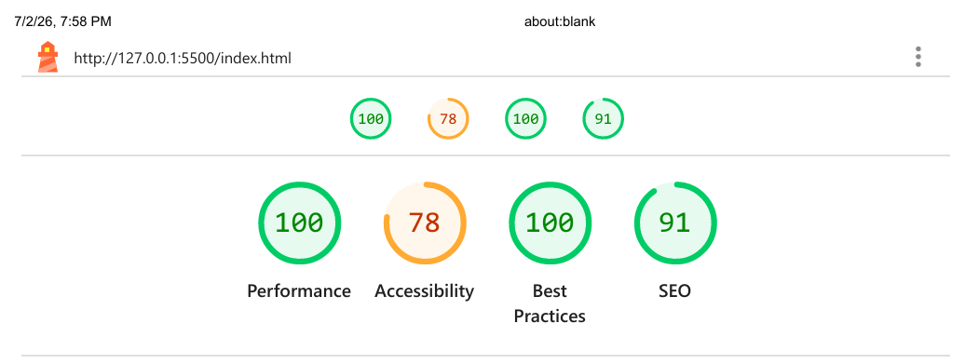
After (91/100 Accessibility):
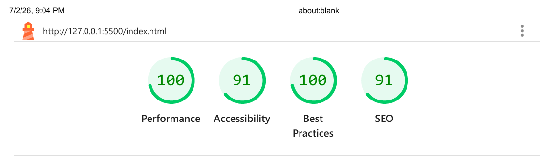

Before vs. After
Check | Before | After
Overall score | 78 / 100 | 91 / 100
Color contrast | h1, h1#projects-heading, and h2 failed the minimum contrast ratio (4.5:1 text / 3:1 large text) | Heading color scheme updated — all elements pass
Heading order | An h4 broke the sequential heading structure (skipped a level) | Heading levels corrected to follow proper document hierarchy
Target size | #nav-bar anchor, mailto link, and Google Maps link were under the 24×24px minimum | Resized / repositioned — all meet the minimum touch target size
Image alt text | Already passing — all images had alt attributes present | Unchanged, still passing

Why This Matters
- Better contrast helps anyone reading in bright light, on a low-quality screen, or with low vision.
- Correct heading order gives screen reader users — who commonly navigate by heading — an accurate outline of the page instead of a confusing jump.
- Larger tap targets reduce mis-taps for touch/mobile users and anyone with motor impairments.
- Meaningful alt text ensures the page still communicates its content when images fail to load or are read aloud.
Process: audit → diagnose → fix → re-audit.

